|  |
| --- |
| Full Stack Web Development Specialization Capstone Project |
| UI Design and Prototyping |
| Course Manager |

|  |
| --- |
| Francisco Villar  4/16/2017 |

1. Introduction

Give a brief introduction to your project and the list of features. Summarize in a few sentences what you proposed in the ideation report.

While developing an app, you go though many different tutorial videos in order to get the skills you need. That’s why I want to create Courses Manager, an app that tracks all the different courses/videos that a user sees to avoid watching a video multiple times if I don’t want to.

In Course Manager the user will be able to login and register to the site. Also, the user will be able to View, Add, Edit and Delete courses from their profile. Finally, and more important, the user will be able to access the about us page.

2. User Interface Design and Prototype

Give some sample user interface layouts for your application. You can use either wireframe diagrams or prototyping tools to construct the mock representations of your UI design

Briefly explain the rationale behind designing your UI and how it is geared towards supporting the list of features for your application.

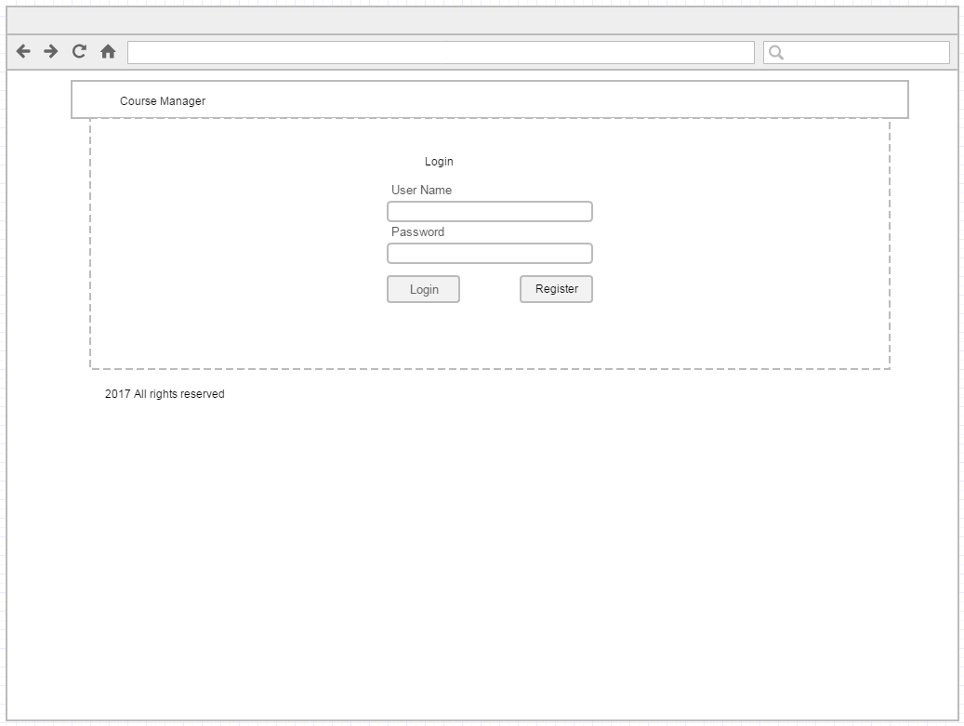

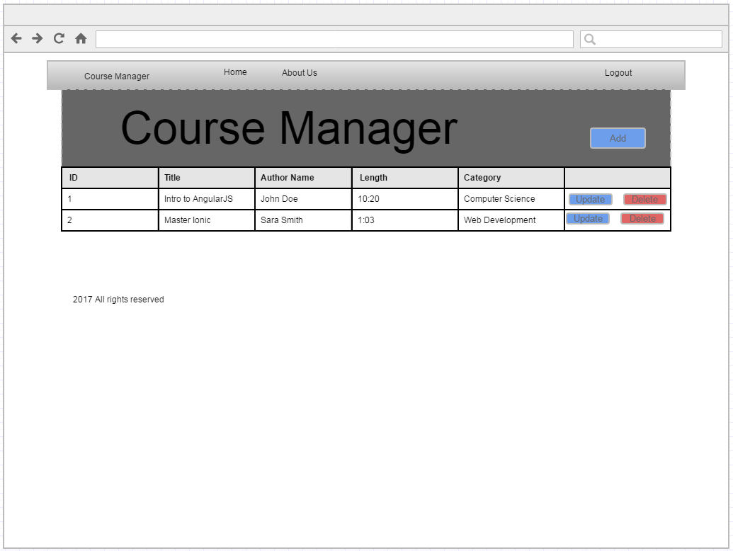

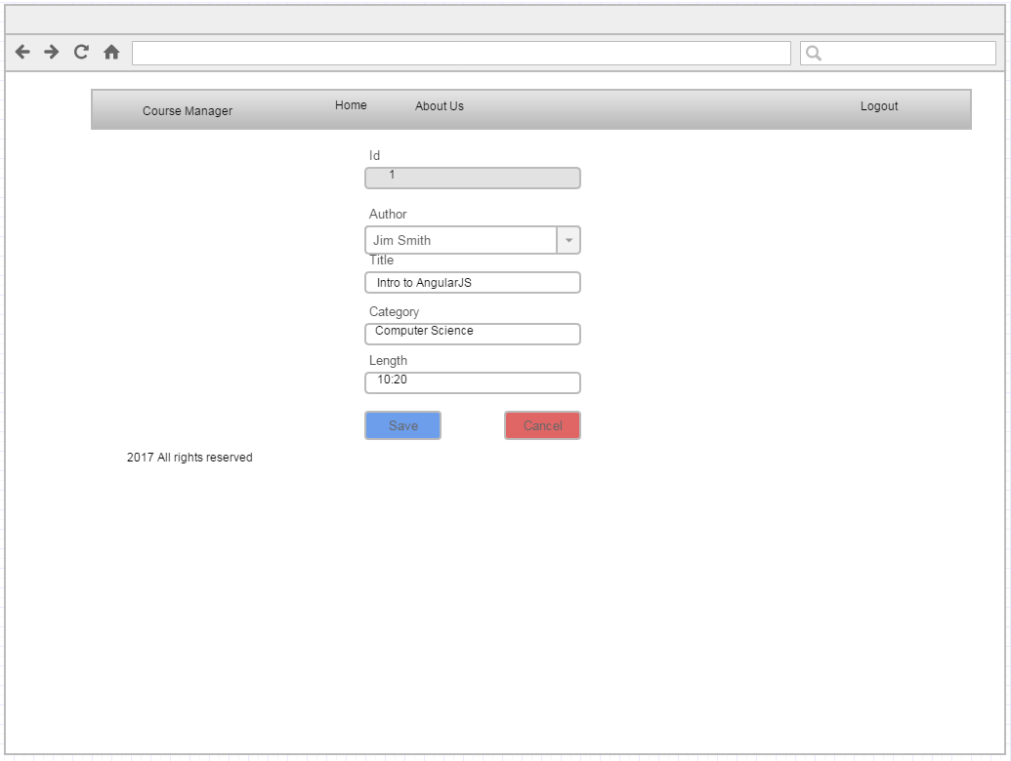

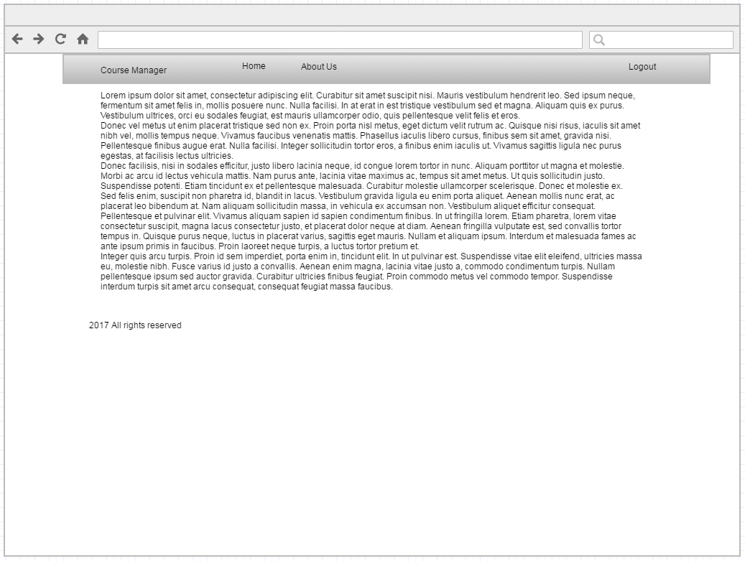

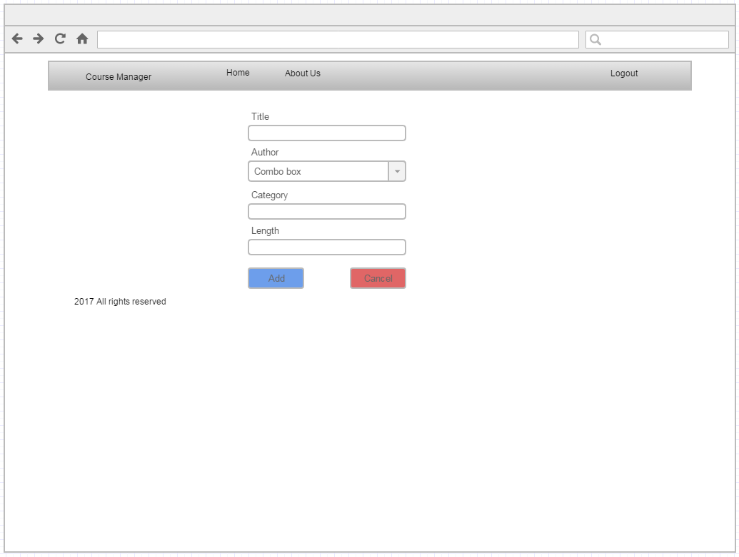

3. Navigation Structure

Give a brief overview of the navigation structure for your application. We touched upon navigation design in the Front-end Web UI Frameworks course.

Briefly indicate a typical flow of your application in terms of user experience. You can use any way of representing the flow. You can also construct a prototype using one of the prototyping tools to illustrate this.

4. References

Provide any references relevant to the report.

Wireframe diagrams <https://www.gliffy.com>